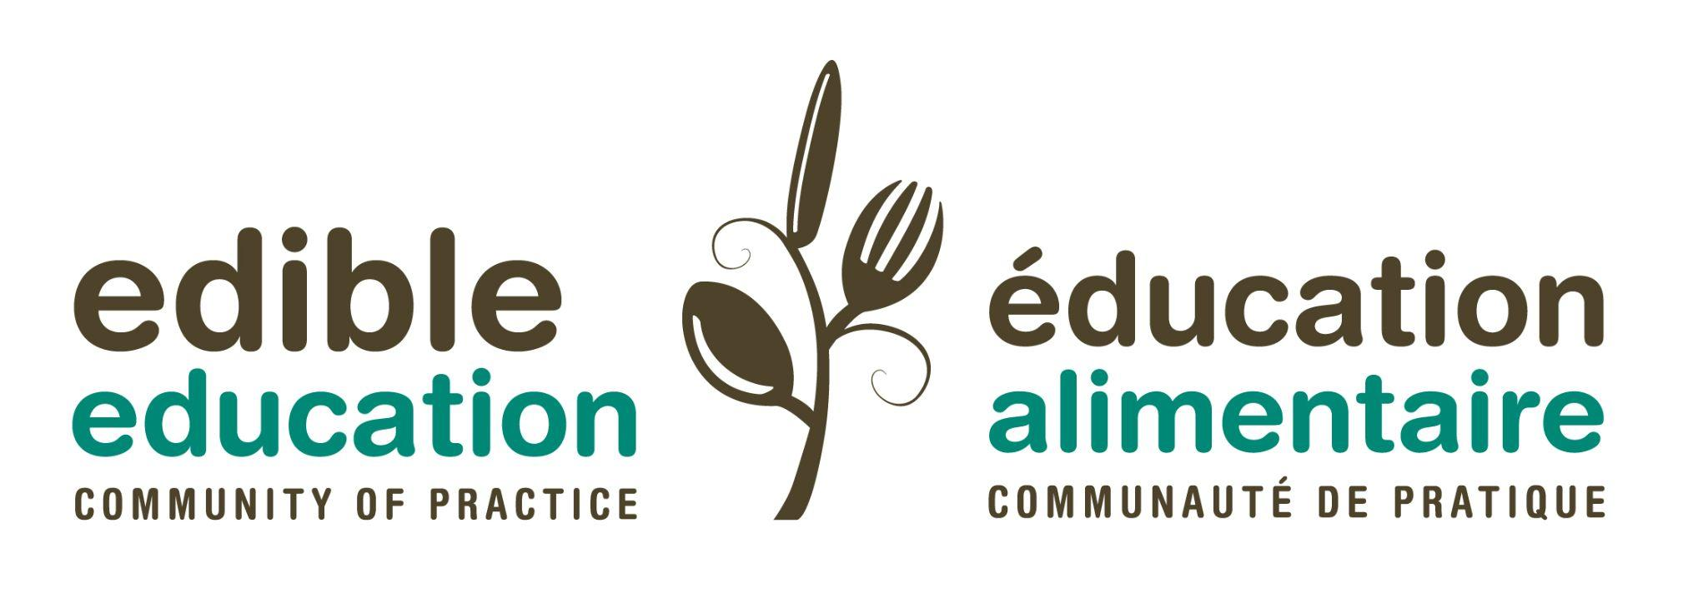

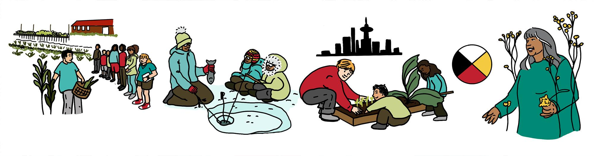
Land-based learning and food system education - a discussion guide
This guide has been developed to help you reflect on the recorded conversation about land-based learning and food system education, and to help inform future discussion at our Community of Practice meeting on November 16th.
Questions - feel free to use the space provided to write down your reflections:
- How is a land-based learning approach different from a more Western approach to education?

- What are some aha! moments about land-based learning and food system education that you had while watching the video?

- What are some shifts that you might want to make within your own approach to food system education to better reflect a land-based worldview?

- What questions arose for you out of the video or what parts of the conversation really spoke to you that you would want to connect with other people about?

