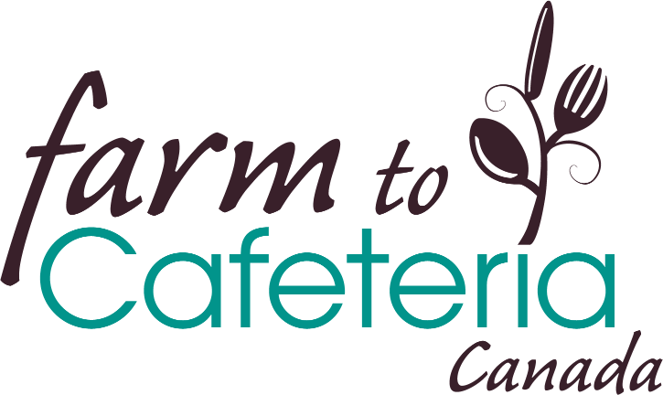

Evaluating Farm to School Programs:
Toolkit to measure priority indicators from the
Farm to School Evaluation Framework for Canada
April 2022
Farm to Cafeteria Canada (F2CC), with the input of over 140 individuals from diverse sectors across the country, developed the Farm to School Evaluation Framework for Canada and shared it in September 2021. This framework articulates priority outcomes and indicators that people want to see measured relating to 4 impact areas: Public Health, Education, Community Economic Development and the Environment.
But how can programs get started with measuring these indicators?
F2CC has developed two survey templates to give school communities, including staff, families, and community partners, some simple tools to measure the success of their farm to school initiatives. This toolkit includes:
A) A survey for school staff or program volunteers
B) A survey for students (could be used for grades 4-12, although each teacher will want to assess whether it is appropriate for their class / school or if it needs to be adapted)

The questions in these surveys have been designed to measure as many of the priority indicators identified in the Farm to School Evaluation Framework for Canada as possible.

We encourage organizations and schools to adapt either of these survey templates to meet your needs, and to use your adapted survey(s) to measure and communicate the impacts of your programs. These surveys can be used:
- As stand-alone tools to give an overview of a farm to school program at a specific point in time AND
- To measure year-after-year progress on your farm to school initiatives
We recommend that multiple staff/volunteers and students at each school complete the surveys to provide a diverse set of responses.

Note that any letter and number combination in brackets - e.g. [PH 1.1] refers to the Evaluation Framework indicator number that it is intended to measure. These identifiers may be useful for those reviewing the survey but may be best to remove when creating and delivering the survey.

For a definition of any of the terms used in these surveys please see Farm to Cafeteria Canada’s Glossary of terms.

These surveys are licenced under the Creative Commons Attribution-NonCommercial-ShareAlike 4.0 International Licence. This means that they may be modified and used however you like except for commercial purposes.

This tool is a work in progress. We welcome feedback on how you’ve used it and what other evaluation tools would be useful for you - reach out at info@farmtocafeteriacanada.ca.
Tool A - School Staff Survey I Reflections on your school’s farm to school program
- Approximately how many students are enrolled at your school?

- How many school staff: [EDU 1.6]
- Play a leadership role in your school’s farm to school program?
- Participate in, or support, your school’s farm to school program?

- Which of the following does your school have access to? [PH 2.3]
  - Indoor or outdoor growing space
  - Land to gather food
  - Kitchen
  - Dedicated eating space
  - Other

- The following information will be used to calculate what percentage of the school’s food budget is spent on local food [CED 1.4]:
a) In the previous school year, how much money did your school spend on its total food budget? (please approximate)

b) In the previous school year, how much money did your school spend on local food? (please approximate)

- How many local procurement contracts or partnerships have you established with local food providers? [CED 1.2]

- How many local procurement contracts or partnerships have you established with local food providers who are underrepresented? [CED 2.1]

- What activities is your school involved in? Please select all that apply. [ENV 1.1 / EDU 3.2 EDU 1.4]
- We grow food
- We do beekeeping
- We harvest / gather local food off the land or from the water
- We use sustainable food production activities [ENV 1.2]
- We cook food
- We preserve food
- We host tasting activities
- We are involved in composting on-site
- We learn from local food providers (e.g. farmers, fishers or gatherers)
- We visit Farmers Markets or other sites to purchase local foods
- We share foods from different cultures that reflect our student population [EDU 4.1]
- Our students participate in a farm to school / local food fundraiser
- We host a food box or backpack program that engages students
- Other:

- How many of your school’s students are engaged in each of these activities? (Please approximate) [ENV 1.1 / EDU 3.2 EDU 1.4]

- Engaging in farm to school activities has impacted our school community in the following ways:

We refer to a number of terms below such as “healthy food” and/or “local food”. To understand how F2CC defines these terms visit our Glossary.
––> Strongly Disagree, Disagree, Neutral, Agree, Strongly Agree, Don’t Know
Public Health:
- Increased the amount of healthy food that our school procures and provides to students
- Increased the amount of healthy food consumed by students [PH 1.1]
- Increased students’ willingness to try new vegetables and fruits [EDU 2.1]
- Increased students’ awareness of nutrition and healthy eating
- Increased students' excitement about healthy eating
- Increased the amount of food produced or harvested by members of the school community and served at school [PH 2.4]
- Improved the school food environment to better promote healthy foods and make them easy to access [PH 2.5]
- Increased students’ ability to access healthy food in a dignified way regardless of their ability to pay [PH 2.8]
- Increased the amount of food grown and/or served at the school that reflect the cultural backgrounds and traditions of the student population [PH 2.9]
- Increased the amount that students’ cultural food traditions are respected and celebrated at school [PH 3.3]
- Increased the number of hours that students spend on garden and other land-based activities [PH 4.1]

Education:
- Increased the number and quality of opportunities for students to learn and demonstrate food skills (ex. gardening, food preparation, etc.) [EDU 1.4]
- Increased students’ hands-on food literacy skills (e.g. growing, harvesting off the land, preserving and cooking, and composting food)
- Increased students’ understanding of their local food system, local foods, local food providers and foods in season [EDU 3.3]
- Increased students’ understanding of foods belonging to different cultures [EDU 4.1]
- Increased the number of students who share their cultural food traditions at school [EDU 4.2]
- Increased how often cultural ceremony in relation to food is demonstrated within the school community [EDU 4.3]
- Increased students’ understanding of diverse traditional Indigenous food systems [EDU 5.2]
- Created a greater sense of vibrancy and excitement in the school
- Increased connections, partnerships and participation within the school and the broader community (e.g. with the Parent Advisory Council, community groups, growers or harvesters, chefs, local authorities, community organizations etc.)

Environment:
- Increased the amount of students that are engaged in their local food system while at school [ENV 1.1]
- Increased the number of school events and activities that raise awareness about sustainable food system practices [EDU 6.1]
- Decreased the amount of food waste produced by students at school [ENV 1.3]
- Increased student knowledge, awareness and interest about environmental and ecological issues
- Increased students’ understanding of how the food system and their own personal choices influence planetary health

Community Economic Development:
- Increased the amount of local food that our school procures and provides to students
- Increased food sales
- Has led our school to be a leader among other institutions in the procurement of healthy, sustainable, local foods
- Increased the number of hours that food service workers and providers are engaged in the school’s food activities (e.g. planning menus, supporting local supply chains, supporting a school garden, training students in knife skills, etc.) [CED 3.2]

Thank you for taking this survey!

Tool B - Student Survey I Reflections on your school’s farm to school program
Your school would like to understand what impact its farm to school activities (e.g. serving local food, food tastings, growing and cooking with food, visiting with food providers or chefs) have had on you.
The survey should take no more than 10-15 minutes to complete.

- If you think about the food activities at your school this year, how much do you agree with the following statements?

Absolutely! / Kind of / Neutral / Not really / Definitely not
OR
Strongly Disagree, Disagree, Neutral, Agree, Strongly Agree, Don’t Know

Because of the food activities at my school (e.g. serving local food, food tastings, growing and cooking with food, visiting with food providers or chefs etc.):

Healthy food:
- Healthy foods are promoted at my school better than they used to be [PH 2.5]
- Healthy foods are easier to access at my school [PH 2.5]
- I have more desire to eat healthy food
- I feel more confident growing, harvesting and preparing food [EDU 1.7]

Local foods and local food system:
- I have more understanding about local foods [EDU 3.3]
- I have more understanding about my local food system and where the food I eat comes from [EDU 3.3]
- I have more understanding about foods in season [EDU 3.3]

Access to food:
- I believe that my peers and friends have more access to meals served at school [PH 2.8]

Culturally appropriate and diverse food:
- I have more understanding about diverse traditional Indigenous foods and food systems [EDU 5.2]
- I feel that the food grown and served at school reflects my cultural background and traditions [PH 2.9]
- I feel that the food grown and served at school reflects the cultural backgrounds and traditions of the students at my school [PH 2.9]
- I feel that my cultural food traditions are respected and celebrated at school [PH 3.3]

Food and packaging waste:
- I reduce more of my food waste at school [EDU 1.3]
- I reduce more of my food packaging waste at school

Personal well-being:
- I have more focus in class
- I have more desire to be at school
- I feel that I belong and am more connected to my school, my peers, school staff, and my broader community [PH 3.2]
- I have better physical and mental health

- Is there a food activity that you’ve participated in this year that you’ve really enjoyed?

- What is one food-related activity that you would love to do more of at school?

- Can you share more information or a story about how participating in these activities at school has affected you?

Thank you for taking this survey!

