Advancing Farm to School in Ontario and BC Grant Guidelines
UPDATED MARCH 15, 2016
All revisions in this updated document are in red font.

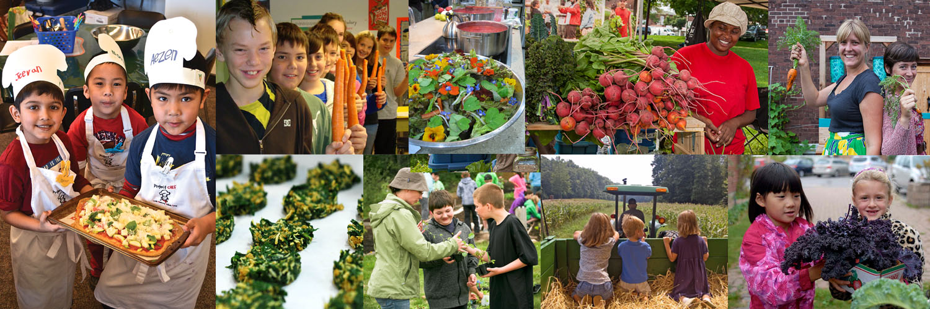

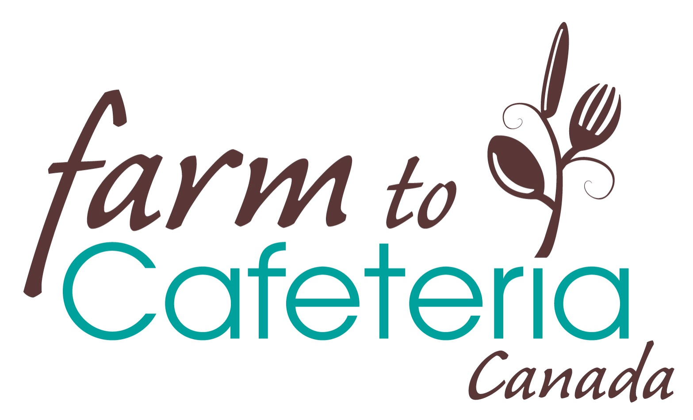
Completed grant application forms plus all required ancillary information noted on the grant check list must be received via email in the Farm to Cafeteria office no later than April 1, 2016. Please email your information to:

Farm to Cafeteria Canada
Canadian Farm to School Grant Project Manager
Email: farm2schoolgrantsCanada@gmail.com

Advancing Farm to School in Ontario and BC
GRANT APPLICATION
Checklist

- Have all the questions been answered/tables completed?
- Have you kept your answers within the maximum word count per question?
- Have the lead applicant and co-applicant signed the cover page?
- Have you included photos of the current food preparation, food service and student dining areas (jpeg format, 5 maximum)?
- Have you included a letter from your local Public Health Inspector (PHI) or Environmental Health Officer (EHO) that (a) indicates that he/she is aware and supportive of your proposed program and (b) outlines any recommendations around equipment, space modifications and/ or food safety training that may be needed to meet food safety requirements?
- Have you described how and when you will address any outstanding food safety recommendations made by your EHO or PHI in your work plan? (See question 3.1)
- Have you included a well-planned budget that reflects the school’s equipment/space modification needs and the EHO or PHI’s recommendations around these needs?
- Have you included evidence that at least one member of your Farm to School team who will be involved in food service has completed or will complete Food Safe Level 1 prior to the launch of your program? (A copy of the Food Safe Level 1 training course certificate OR a copy of the confirmation of registration in this course will suffice).
- Have you included quotes for any single item equipment purchases over $1,500.00?
- Is your School District / Board aware, and supportive, of this application?
- If your school operates a meal service, is your current food service lead aware and supportive of this application?

To apply please send the following items by email:
- Your completed and signed application form (in pdf format)
- Your photos (in jpeg format)
- A letter from your PHI or EHO (in pdf format)
- Evidence that at least 1 member of your F2S team has completed or will complete a Food Safe Level 1 training course
- Quotes for any single item equipment purchases over $1500.00
To:
Farm to Cafeteria Canada
Canadian Farm to School Grant Project Manager
Email: Farm2schoolgrantsCanada@gmail.com

All applications must be received in electronic format no later than April 1, 2016. Further questions or inquiries may be directed to the Canadian Farm to School Grant Project Manager. Email: Farm2schoolgrantsCanada@gmail.com

Please note, successful applicants will be required to identify at least 1 lead (the applicant, the co-applicant and/or the Farm to School Program Coordinator) to participate in an orientation and training session in September 2016.
Advancing Farm to School in Ontario and BC
GRANT APPLICATION
Cover Sheet

Date:
To: Farm to Cafeteria Canada
Canadian Farm to School Grant Project Manager
Email: Farm2schoolgrantsCanada@gmail.com

Lead Applicant (Principal):

The lead applicant must be the school Principal, Vice Principal or someone with equivalent decision making authority at the school. If more than one school will be engaged in the proposed program, list the other school(s) plus the name(s) of the principal(s) and school information on a separate sheet.

Name of Lead Applicant:
Title of Lead Applicant:
Name of school:
School District # (BC) or School Board (Ontario):
Number of Students: Grades taught:
Email: Phone:
Address:
City: | Province: | Postal Code:

Co-Applicant (Community Partner):

The co-applicant must be a community partner who can provide additional expert technical support to the school community to help them realize their program vision and goals AND to ensure the proposed program is tied to and supports the sustainability of the local food system. If you are uncertain whether or not your Co-Applicant qualifies please contact the Canadian Farm to School grant Project Manager at: Farm2SchoolgrantsCanada@gmail.com.

Name of Co-applicant:
Title of Co-applicant:
Name of the community organization or agency:
Email: Phone:
Address:
City: | Province: | Postal Code:

Date program planning with team commenced: |  | Date program deliverables will be complete:
Total Amount Requested From Farm to Cafeteria Canada | : | Total Program Cost: | $

Signature of the Lead applicant:_______________________ Date:____________________

Signature of Co-applicant: ___________________________ Date:____________________
Advancing Farm to School in Ontario and BC
GRANT APPLICATION

Section 1: Proposed program at a glance

1.1) What are you planning to do? Provide a succinct description of your proposed Farm to School program. (Maximum 300 words).

Include the vision, goals and key program components. Refer to the grant guidelines pages 5 and 6 to ensure that your program meets the granting criteria.

1.2) Who will be involved? Please identify the members of your Farm to School team in the table on the next page. Provide their contact information and describe their roles in your proposed program.

Successful Farm to School programs are created and supported by strong community relationships and a committed team of people. We have identified typical core team members with an (*), along with their potential roles in the table on the next page. Many options of additional people who typically comprise a Farm to School team are also provided. We recognize that team members and their roles will vary depending on the specific context. For example the Principal may elect to take on some of the work of the F2S program coordinator and the Community Partner may take on some of this work as well. This might reduce/eliminate the need for a separate Farm to School coordination position. Please complete the table and modify the information to suit your specific situation.

Team member | Name(s), Email, Phone | Name of school, organization, farm, business… | Role with proposed F2S program
* Principal /  Vice Principal  (Lead Applicant) |  |  | Provides leadership and program over-site.  Ensures program funds are administered and deliverables are met.  Other activities include…
*Farm to School Program Coordinator |  |  | Coordinates the day-to-day school-based activities of the proposed program.  Key activities will include..
*Community Partner  (Co-Applicant) |  |  | Ensures the proposed program is tied to and supports the sustainability of the local food system.  Provides additional expert technical support to the school community to realize program vision, goals and deliverables.  Specific, support services will include…
*Food Service Lead  (If the school currently offers a school meal service – this individual must be meaningfully engaged in the proposed program) |  |  | Coordinates the day-to-day activities of the school food service.  Supports the food service aspects of the proposed program by…
* PAC/School Council Representative |  |  | Supports Farm to School program through fundraising, securing volunteers, and/or ..  Aligns their food service activities with the vision and goals of the proposed program by…
Local Farmers /food producers  (Farmers may be busy individuals, but their support is integral to program success. Connect with your local food producers early on and extend an invitation to a farmer to be a part of the F2S team) |  |  | Produce foods for the proposed Farm to school salad bar program and…
Environmental Health Officer or Public Health Inspector  (EHO/PHI may be busy individuals, but their support is integral to program success. We encourage connecting with your EHO/PHI early on and to extend an invitation to be part of the team) |  |  | Reviews and approves food safety aspects of proposed program by..
Students

Teachers

Gardeners

Elders
Chefs/culinary arts instructors

Community Nutritionist or Public Health Dietician

Others

Section 2. School food system at a glance

2.1) What activities are currently underway at the school to get healthy local foods on the minds and on the plates of students?

Please fill in the table below and email photos of the food preparation, food service, and student dining areas (5 photos maximum, jpeg format)

Garden or Greenhouse on premises? ____Yes ___No
Average number of students engaged in educational garden/greenhouse activities annually:
Kitchen on premises? ___Yes ____No
If a kitchen is available, does this kitchen have the following equipment (Check all that apply)
____a 2-3 compartment sink? ____a refrigerator? ____a dishwasher? _____a freezer?
____ a salad bar unit? ____ a stove?
Average number of students engaged in educational cooking activities annually:
Are any of the following meals or snacks provided at the school? (please check all that apply)
___Breakfast?___ Lunch? ___ Salad Bar?___Snacks?
If meals or snacks are provided, who coordinates those services? (check all that apply)
Breakfast:___School Staff, ____Parents/PAC/School Council, ___ Contracted out to ____________ food service company
Other _________________
Lunch:__School Staff, ____Parents/PAC/School Council, ___ Contracted out to ____________ food service company
Other _________________
Snack: ___School Staff, ____Parents/PAC/School Council, ___ Contracted out to ____________ food service company
Other _________________

Estimated amount the school spends on the purchase of local foods annually: __________
Average number of students who participate in the lunch meal service when offered:
Composting program on premises? ___Yes ___No
Local food procurement policy in place? ___Yes _____No
Student nutrition policy in place? ____Yes _____No
Are there any other school food system activities underway at your school that we should be aware of?

Section 3. Program plan - A closer look

3.1) How will the proposed program get more healthy local foods on the minds and plates of all students? (Maximum 500 words)

We are looking for a work plan. Consider providing information in a chart format – include key activities, outputs, estimated dates of completion. Remember, all deliverables for the proposed program must be complete by June 30, 2017.

3.2) Hands-on learning and food literacy are core elements of Farm to School. Describe the experiential educational components of your program. How will the program build upon existing activities to improve student knowledge about the local food system, growing, procuring, preparing food, sharing food, managing food waste and/or healthy eating? (Maximum 200 words)

3.3) Access to healthy local food is a core element of Farm to School. Describe your salad bar service. (Maximum 300 words)

Questions to consider in your response: What foods will you strive to serve in the salad bar? How many servings of fruit and vegetables will be offered? What percentage of foods will be local? Where will the salad bar be located in your school? To what extent will the service be integrated into existing food service? Who will oversee the day-to-day operations of the service? To what extent will students be engaged in the salad bar service? How often will you offer the salad bar service (days/week; weeks/school year)?

3.4) Food safety is a critically important aspect of your Farm to School salad bar program. Describe what activities have been undertaken/ will occur to ensure your proposed program meets food safety requirements. (Maximum 100 words)

The Environmental Health Officer (EHO) or Public Health Inspector (PHI) in your area should be contacted in the early planning stages of proposal development. Your local EHO or PHI will need to verify the equipment, space and food safe training needs for your program if you plan to start or change an existing food service.

3.5) Where will you source local food for your Farm to School program?

A “farm” is a key component of any Farm to School program. Supporting local farmers/food producers and the local food economy are key aims. All schools that are recipients of Canadian Farm to School grants are expected to reach out to local farmers/food producers – either directly or through the local food supply chain – in order to purchase foods for the school salad bar service. Community partners can assist schools with the task of sourcing, procuring, preparing and serving local foods. We expect schools to set realistic local food procurement targets and to increase those targets annually.

While a school garden compliments a Farm to School program, and is a strong addition to Farm to School programs increasing food literacy and increasing access to food that students have grown themselves in school meals, it is not synonymous to or a substitute for a local farm/local food producer/supplier of local food. School-yard farms or school-yard market gardens that operate as a business producing and selling food, qualify as farms.
Food Source | Check all that Apply (Yes or No) | Name of farm/business/or organization you will source from | Agreement in Place  (Yes or No)  If Yes, Describe
Farmer / Farmers’ Market
Community /Market Garden
School Garden / School Greenhouse
Food Distributor
Grocery Store / Other

3.6) What is your plan for distribution of the local food? How will the food get to the school? Who will be responsible for receiving and properly storing the food? (Maximum 100 words)

3.7) Please describe how your school plans to ensure all students have access to the salad bar program regardless of means. If subsidies are required, please describe the source of funding you will use. (Maximum 100 words)

3.8) Please describe how your Farm to School program plans to mitigate waste and address environmental sustainability (if applicable). Examples include using re-usable containers or utensils, composting, etc. (Maximum 100 words)

3.9) How will you ensure the financial sustainability of your Farm to School program and your ongoing relationship with your community partner beyond the 2016-2017 school year? (Maximum 250 words)

Can you provide a small business plan that illuminates key annual anticipated costs for the operationalization of your program and how you plan to recover their costs beyond the 2017 year?

3.10) How do you plan to measure the success of your program? This can really be as simple as looking at the goals of your program and determining how you will measure these goals. (Maximum 200 words)

3.11) How do you plan to promote your program and to share your Farm to School story? (Maximum 150 words)

When responding consider these questions: How will you engage the school community in your Farm to School salad bar? How will you communicate with parents? What actions could you take to share your new project with the broader community?

Advancing Farm to School in Ontario and BC
GRANT APPLICATION

Section 4. Budget
Item | Description of Item | Amount available from other sources (include cash or in kind contributions.) | Amount requested from Farm to Cafeteria Canada
Salaries |  | $ | N/A
Honorariums - for initial program coordination.  While it is expected that Farm to School programs will be self-financing after 6 months of operation, a maximum of 25% of the funding may be earmarked to support honorariums for initial on-site program coordination activities. |  | $ | $
Community partnerships.  A maximum of 10% of the funding may be earmarked to bring community partners to the table – individuals who can provide additional expertise and technical training/resources to ensure the proposed program is tied to and supports the sustainability of the local food system. |  | $ | $
Training.  15% of the funding must be earmarked to support travel and accommodation costs so that program lead(s) can participate in educational training opportunities hosted by Farm to Cafeteria Canada in BC and Ontario to help plan, implement, sustain, evaluate and share knowledge over the course of the grant period. Details of dates and locations will be shared once finalized. |  | $ | $
Equipment  Can include the following:  Kitchen equipment at the school such as refrigerators, freezers, salad bar units, food warmers, food processors, soup pots, dishes cutlery, storage bins, cutting boards, knives, soap and towel dispensers, etc.  Equipment and material costs for the growing of food such as seed, soil, lumber, garden tools, composting unit, green house materials, etc.  Maximum amount allowable for any single piece of equipment = $3000  Quotes are required for a single piece of equipment over $1500 in cost. |  | $ | $
Space modification costs  Maximum amount allowable = $3000 |  | $ | $
Promotional/Educational Supplies |  | $ | $
Food for initial salad bar service  Not to exceed $3.00/child participating in the program |  | $ | $
Food following the initial start up |  |  | N/A
Total amount requested from Farm to Cafeteria Canada: $
(Not to exceed $10,000/school)








